Dharma Devi 22nd and 23 rd April HW

**Create a Dataflow pipeline using Python**

**Code Executed to read the File**

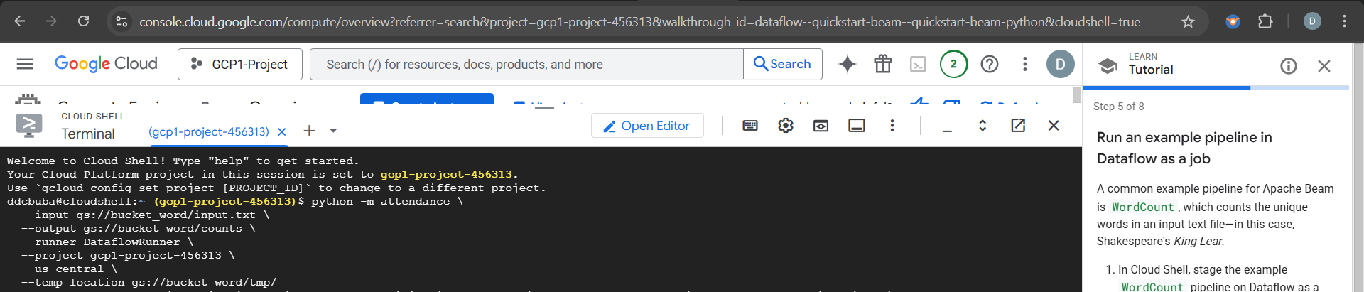

**The output file is created where the content is available**

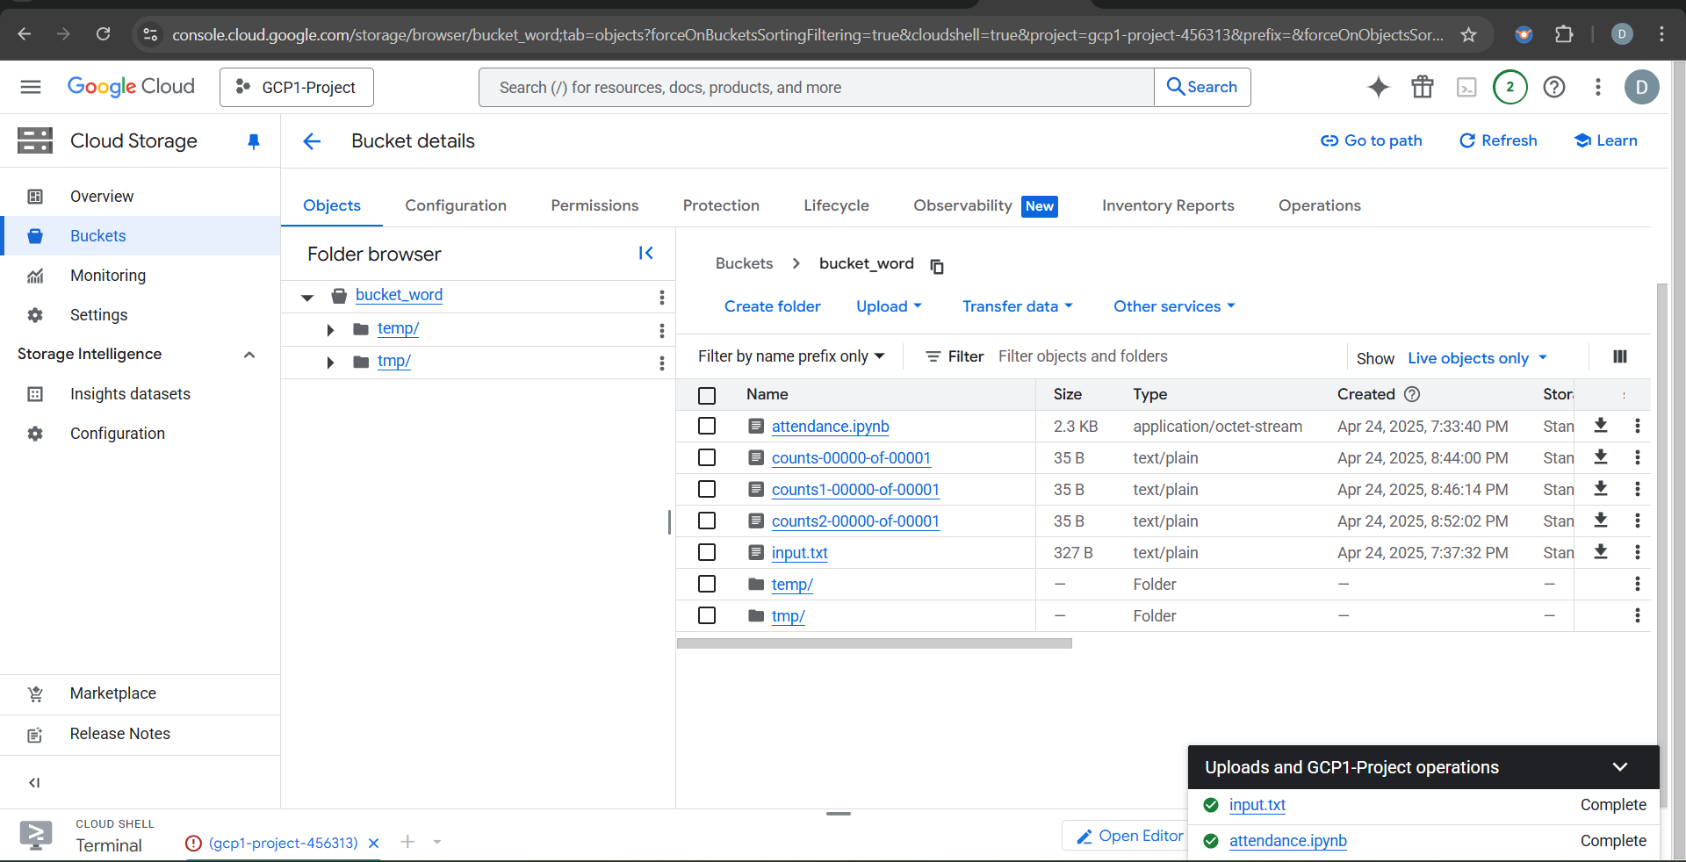

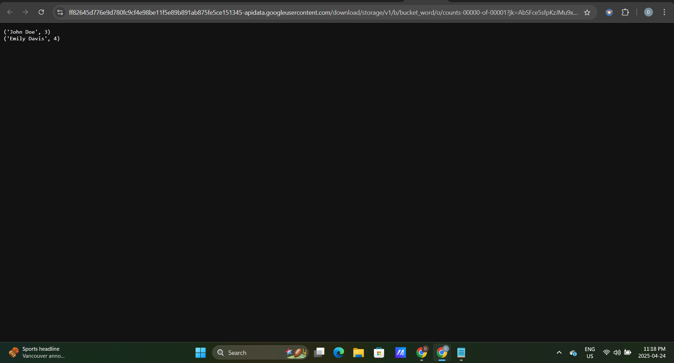

Checked for Python Version

23rd HW

Jobs with beam app

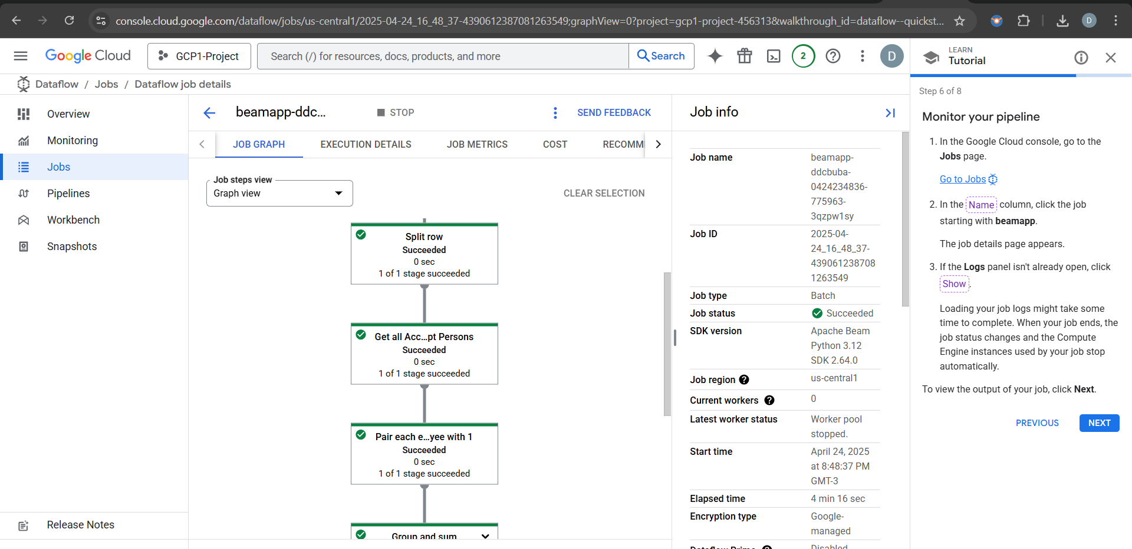

LOGS PANEL

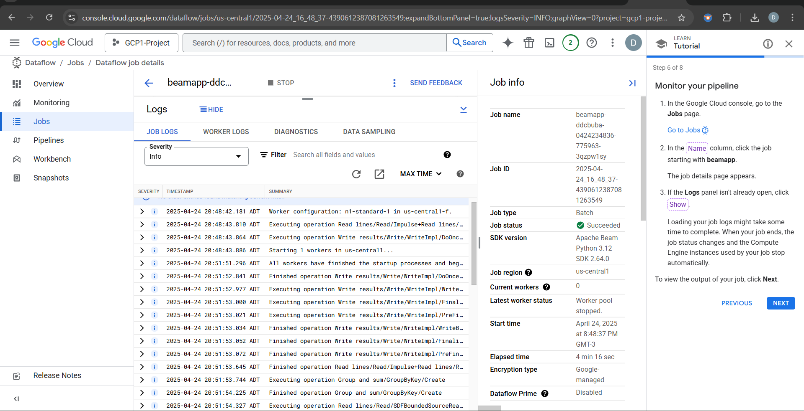

Apache beam installed

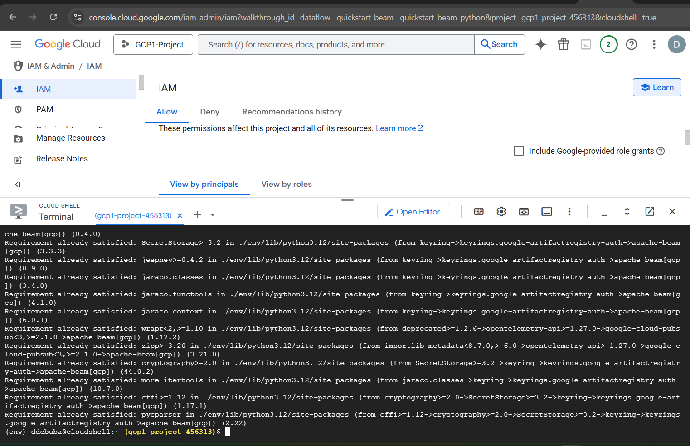

Job State Completed with Data Flow

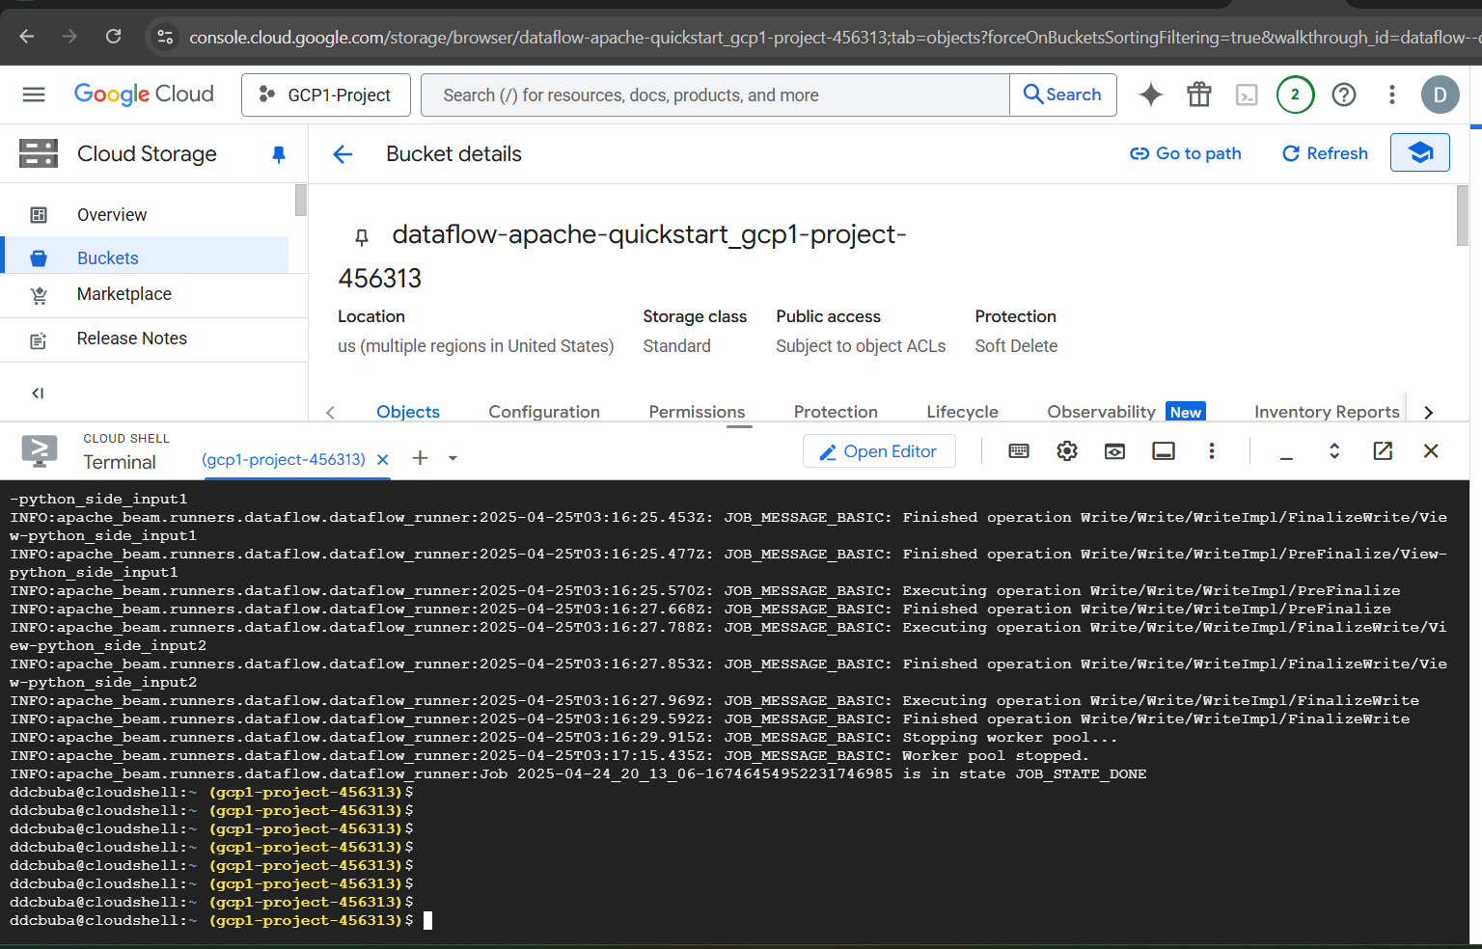

Results Output

